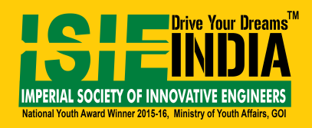
FACULTY DEVELOPEMENT PROGRAM
on
SUSTAINABLE SOLAR SKILLS DEVELOPMENT
(10th – 16th December 2018)
Regsistration Form
Name :
(In captial letters as required in Certificate)
Designation :
Department :
College/ Institute Name :
Mobile No. :
Email id :
Payment Refernce Number :

